## **Packet Tracer**



# **Pcaket Tracer**



O Packet Tracer é um programa educacional gratuito que permite simular uma rede de computadores, através de equipamentos e configurações presente em situações reais. O programa apresenta uma interface gráfica simples, com suportes multimídia que auxiliam na confecção das simulações. [Wikipédia](https://pt.wikipedia.org/wiki/Packet_Tracer)

[**Desenvolvedor**](https://www.google.com/search?rlz=1C1GCEU_pt-BRBR1047BR1047&sxsrf=APwXEddKH8ZvwLXdZZp0zNiF0KbjpJhh8A:1681911401891&q=packet+tracer+desenvolvedor&sa=X&ved=2ahUKEwizzpydiLb-AhVaGLkGHbosAJMQ6BMoAHoECFgQAg)**:**[Cisco Systems](https://www.google.com/search?rlz=1C1GCEU_pt-BRBR1047BR1047&sxsrf=APwXEddKH8ZvwLXdZZp0zNiF0KbjpJhh8A:1681911401891&q=Cisco+Systems&stick=H4sIAAAAAAAAAONgVuLQz9U3SMktKVjEyuucWZycrxBcWVySmlsMAChc1fMcAAAA&sa=X&ved=2ahUKEwizzpydiLb-AhVaGLkGHbosAJMQmxMoAXoECFgQAw)

[**Sistema operacional**](https://www.google.com/search?rlz=1C1GCEU_pt-BRBR1047BR1047&sxsrf=APwXEddKH8ZvwLXdZZp0zNiF0KbjpJhh8A:1681911401891&q=packet+tracer+sistema+operacional&sa=X&ved=2ahUKEwizzpydiLb-AhVaGLkGHbosAJMQ6BMoAHoECFkQAg)**:**[Windows](https://www.google.com/search?rlz=1C1GCEU_pt-BRBR1047BR1047&sxsrf=APwXEddKH8ZvwLXdZZp0zNiF0KbjpJhh8A:1681911401891&q=Windows&stick=H4sIAAAAAAAAAONgVuLQz9U3MCmKt1jEyh6emZeSX14MAFTjqsQWAAAA&sa=X&ved=2ahUKEwizzpydiLb-AhVaGLkGHbosAJMQmxMoAXoECFkQAw) ([XP](https://www.google.com/search?rlz=1C1GCEU_pt-BRBR1047BR1047&sxsrf=APwXEddKH8ZvwLXdZZp0zNiF0KbjpJhh8A:1681911401891&q=XP&stick=H4sIAAAAAAAAAONgVuLQz9U3sDDNMljEyhQRAAAw1IUeEQAAAA&sa=X&ved=2ahUKEwizzpydiLb-AhVaGLkGHbosAJMQmxMoAnoECFkQBA), 2000, [Vista](https://www.google.com/search?rlz=1C1GCEU_pt-BRBR1047BR1047&sxsrf=APwXEddKH8ZvwLXdZZp0zNiF0KbjpJhh8A:1681911401891&q=Vista&stick=H4sIAAAAAAAAAONgVuLUz9U3MDc0SzJbxMoalllckggAHQQMTxUAAAA&sa=X&ved=2ahUKEwizzpydiLb-AhVaGLkGHbosAJMQmxMoA3oECFkQBQ)), [Linux](https://www.google.com/search?rlz=1C1GCEU_pt-BRBR1047BR1047&sxsrf=APwXEddKH8ZvwLXdZZp0zNiF0KbjpJhh8A:1681911401891&q=Linux&stick=H4sIAAAAAAAAAONgVuLUz9U3SCuoqipYxMrqk5lXWgEATgerNhUAAAA&sa=X&ved=2ahUKEwizzpydiLb-AhVaGLkGHbosAJMQmxMoBHoECFkQBg) ([Ubuntu](https://www.google.com/search?rlz=1C1GCEU_pt-BRBR1047BR1047&sxsrf=APwXEddKH8ZvwLXdZZp0zNiF0KbjpJhh8A:1681911401891&q=Ubuntu&stick=H4sIAAAAAAAAAONgVuLUz9U3MK4wLcxdxMoWmlSaV1IKAHLVLXAWAAAA&sa=X&ved=2ahUKEwizzpydiLb-AhVaGLkGHbosAJMQmxMoBXoECFkQBw), [Fedora](https://www.google.com/search?rlz=1C1GCEU_pt-BRBR1047BR1047&sxsrf=APwXEddKH8ZvwLXdZZp0zNiF0KbjpJhh8A:1681911401891&q=Fedora&stick=H4sIAAAAAAAAAONgVuLSz9U3MCqoKK8yXMTK5paakl-UCAB5TC8bFwAAAA&sa=X&ved=2ahUKEwizzpydiLb-AhVaGLkGHbosAJMQmxMoBnoECFkQCA))

[**Tamanho**](https://www.google.com/search?rlz=1C1GCEU_pt-BRBR1047BR1047&sxsrf=APwXEddKH8ZvwLXdZZp0zNiF0KbjpJhh8A:1681911401891&q=packet+tracer+tamanho&sa=X&ved=2ahUKEwizzpydiLb-AhVaGLkGHbosAJMQ6BMoAHoECFoQAg)**:**129 MB

[**Plataformas**](https://www.google.com/search?rlz=1C1GCEU_pt-BRBR1047BR1047&sxsrf=APwXEddKH8ZvwLXdZZp0zNiF0KbjpJhh8A:1681911401891&q=packet+tracer+plataformas&stick=H4sIAAAAAAAAAOPgE-LSz9U3MK2qSMkq0VLIKLfST87PyUlNLsnMz9Mvzk8rKU8sSrUqyEksScsvyl3EKlmQmJydWqJQUpSYnFqkAJJIBMkkFgMAK1jCh0wAAAA&sa=X&ved=2ahUKEwizzpydiLb-AhVaGLkGHbosAJMQ6BMoAHoECGEQAg)**:**[Microsoft Windows](https://www.google.com/search?rlz=1C1GCEU_pt-BRBR1047BR1047&sxsrf=APwXEddKH8ZvwLXdZZp0zNiF0KbjpJhh8A:1681911401891&q=Windows&si=AMnBZoFk_ppfOKgdccwTD_PVhdkg37dbl-p8zEtOPijkCaIHMqgrqoZlFSUwYOaQpT5xT3zFmmlYk6TJl-J-VZe0XLH2ZdYvgvKlcCL-Whc0DrIC07uYoftp9toyT95PNa-O5C5MR7WCW4_0pnLtZaE0akgjTK2DRAId9Wpsblm2OzXzZ3Fpf7aKcVCSfHWXHuBXQQZgTofFMvboIbO0WJkS4RmfhBHEW46pcd2jjG3Vws1l-v8lsAc8ocfN0SG3Xxlanx1HiN6Sb7yVVls1RhHew7V70xL2Ag%3D%3D&sa=X&ved=2ahUKEwizzpydiLb-AhVaGLkGHbosAJMQmxMoAXoECGEQAw), [Android](https://www.google.com/search?rlz=1C1GCEU_pt-BRBR1047BR1047&sxsrf=APwXEddKH8ZvwLXdZZp0zNiF0KbjpJhh8A:1681911401891&q=Android&si=AMnBZoG3cRyxvViEiVWeqgrn-CuWcnxp6_6_G7EH225wAKYHQsWNw90lbSuqp5XFdrBk0TYstejZO2oGJCuL0QdRQRCOgh07IEBkFr15KS04xpzP14-fyAsw_C1goU9QKr8qs8LhqXsu9-DSzue6jg7y5qv4SIrJImuexc7JjMg-6urPnt-hy0ml87N0Z0dknyG7-4yfjJGrOQBzXBXBD3Ela_jG1rbfrvXhUWRVqoSJXpcLe7sKpUXvK_T7WCHX9zfwhqjGeRXf3F4DEmBIYVrj2WwLVvdatQ%3D%3D&sa=X&ved=2ahUKEwizzpydiLb-AhVaGLkGHbosAJMQmxMoAnoECGEQBA), [iOS](https://www.google.com/search?rlz=1C1GCEU_pt-BRBR1047BR1047&sxsrf=APwXEddKH8ZvwLXdZZp0zNiF0KbjpJhh8A:1681911401891&q=iOS&si=AMnBZoG3cRyxvViEiVWeqgrn-CuWcnxp6_6_G7EH225wAKYHQnY-FYftm7V4ZjOtAi4JahXeQkyPXQ73XUW0SEc-_IflbiaodHUUMRseZscjlrRAbuFGxziU_OmqkcPpD3U_bTcChYeJd8jbTvaM8xcGJpps7X3V6Qve_rK4HNr1pj5ZR4aeTFo2zRVsfe44JP3ZJ3UlRZXpIaDj_5COF61tSwbwbUB-bV4OxI_YOqlugwSmQVMjKMGIMZa3ynRjBIeSCJ2JyP2D8GQ7HXQAbceE3PoB3M03Iw%3D%3D&sa=X&ved=2ahUKEwizzpydiLb-AhVaGLkGHbosAJMQmxMoA3oECGEQBQ), [MacOS](https://www.google.com/search?rlz=1C1GCEU_pt-BRBR1047BR1047&sxsrf=APwXEddKH8ZvwLXdZZp0zNiF0KbjpJhh8A:1681911401891&q=MacOS&si=AMnBZoFk_ppfOKgdccwTD_PVhdkg37dbl-p8zEtOPijkCaIHMq7OclITh-k1pYc0I5FT95gUYeYeyfzMiN4qPULwnXTdZWwKJ35DOghivn-Axh3cHKgOkhA82S1JRGeA_J6akqL4QAhYjEIP3MHruf3qd4Rq02kEEvnEE5AxFjEe9MdRK1w8e8Sonct4W643QnEmH5WiK_MhS5HLmnkdXYQCNV5S7Yqc4jDFWCpUlx1MTf9YBfj0uBOplOfhPUPZo22oBCB6rklR&sa=X&ved=2ahUKEwizzpydiLb-AhVaGLkGHbosAJMQmxMoBHoECGEQBg)

# **Logical**

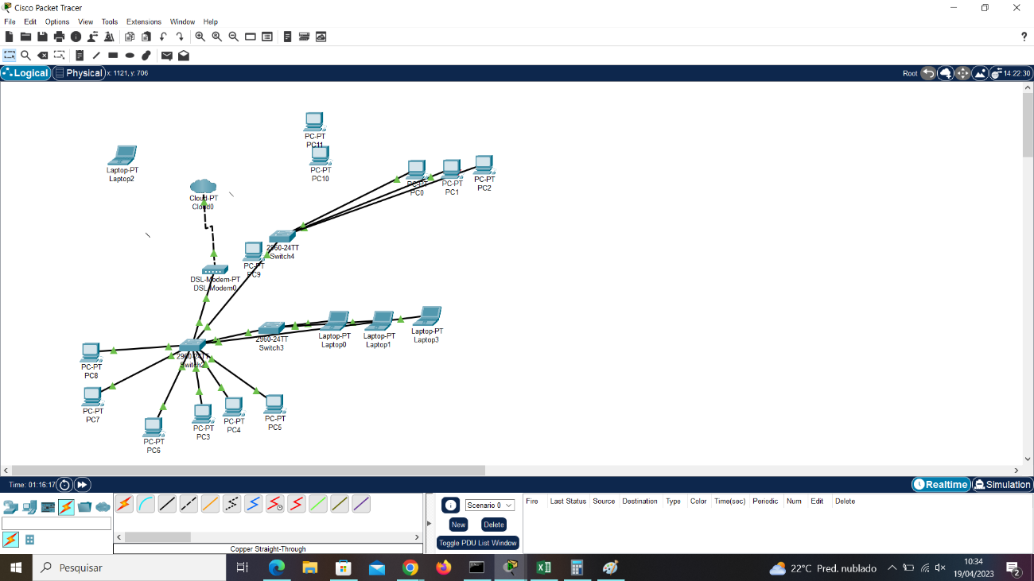

# 

# **Physical**

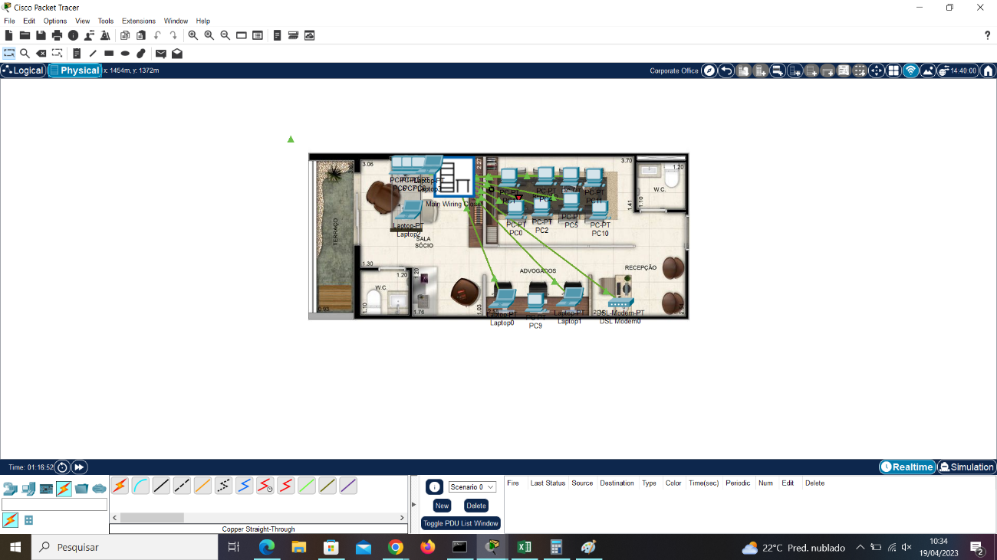

# 

**Valores**